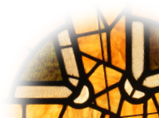
Kensington Presbyterian Church
Growing in faith and sharing God’s love
since 1786
Contagious Sharing
June 14, 2026
Welcome, we come to you from the un-ceded lands of the Kanien’kehá:ka Nation.
We are offering a variety of ways for people to gather. We are welcoming people to worship in person, as well as through Zoom, YouTube, and this printable PDF. If this is how you are worshipping, know that you are not alone... and if you like, you can invite others to join you. Clicking on or tapping blue text will take you to a web-site.
If you have any prayer requests, ideas, or just want to talk, please reach out to your elder or Rev. Peter (Peter@Kensingtonchurch.ca).

Announcements
Sunday Singing: Join Zoé on Sundays at 9:50 to share in the music
Prayer Groups:
Women’s Prayer Group: Tuesday afternoon (last of season)
Zoom: Wednesday at 6:30 am
Bible Study: Wednesday 7-8 pm
Join us in the minister’s office and over zoom
as we discuss the upcoming week’s main scripture passage.
Friday Friendly Food & Film Series: 6:30 pizza, followed movie
June 19: Zootopia (last of the season)
New Hope Opportunities - in our basement
Tech Time: Tuesday, June 16, 1-3pm
AGM & BBQ - Wednesday, June 17 at 11am
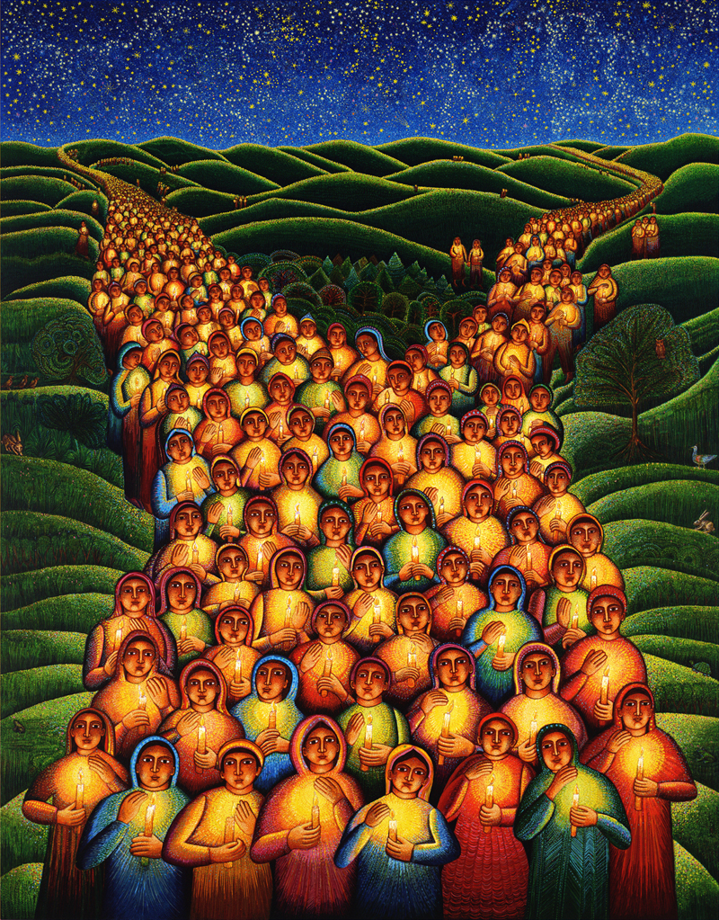
Festival of Lights - J Swanson

Contacts
Church Office: 514-486-4559 info@Kensingtonchurch.ca
Rev. Peter Rombeek (pastor) Peter@Kensingtonchurch.ca
514-773-4620
Zoé Dupont-Foisy (music director) zoedupontfoisy@hotmail.com
Orly (Outreach co-ordinator) orly.kensington@gmail.com
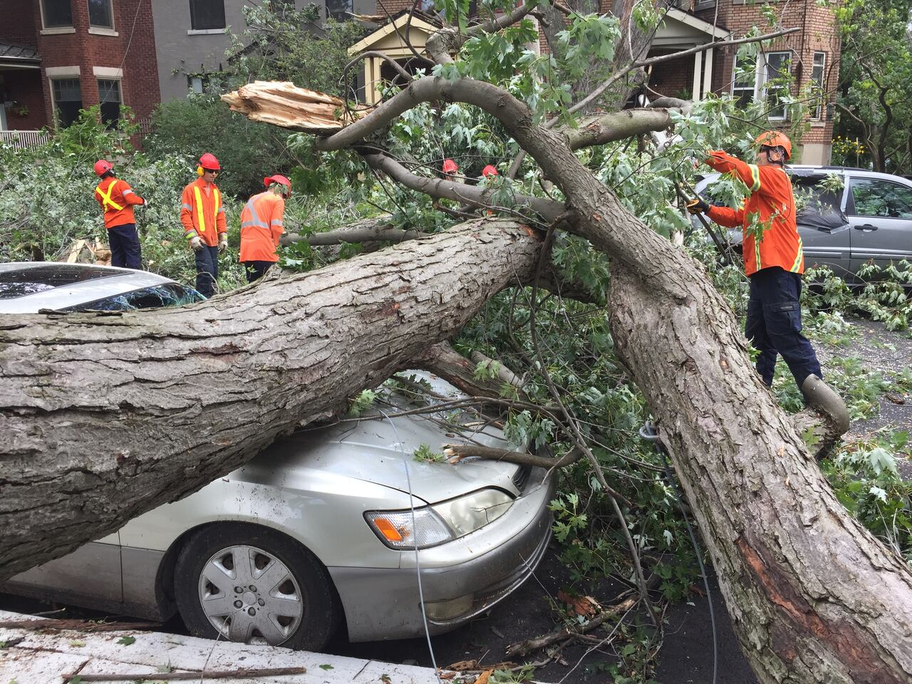
Rose Ngo Mbenoun (Clerk of Session) admin@Kensingtonchurch.ca

Approaching God


Lighting of the Christ Candle
Jésus Christ est la lumière du monde.
Jesus Christ is the light of the world.


Call to worship
The God of the whirlwind and fire
sweeps into our presence in this hour.
Glory be to God, who strengthens us
and blesses all people with peace.
God, who called all the world into being,
calls forth new life in us today.
Glory be to God, in whose creative.
purpose we are claimed and empowered.
God, whose Spirit unites all people
in a common language of love,
confirms God’s gifts in us as we gather here.
Glory be to God, who created light in which
we can walk in confident expectation.

♫ Hymn: All hail the power of Jesus' name pg 9 (363)
www.youtube.com/watch?v=tmxCpX28-Gc


Prayer of Approach
While Rose will be leading our prayer, you are welcome to use this one from The Worship Sourcebook Q.1.4.4.
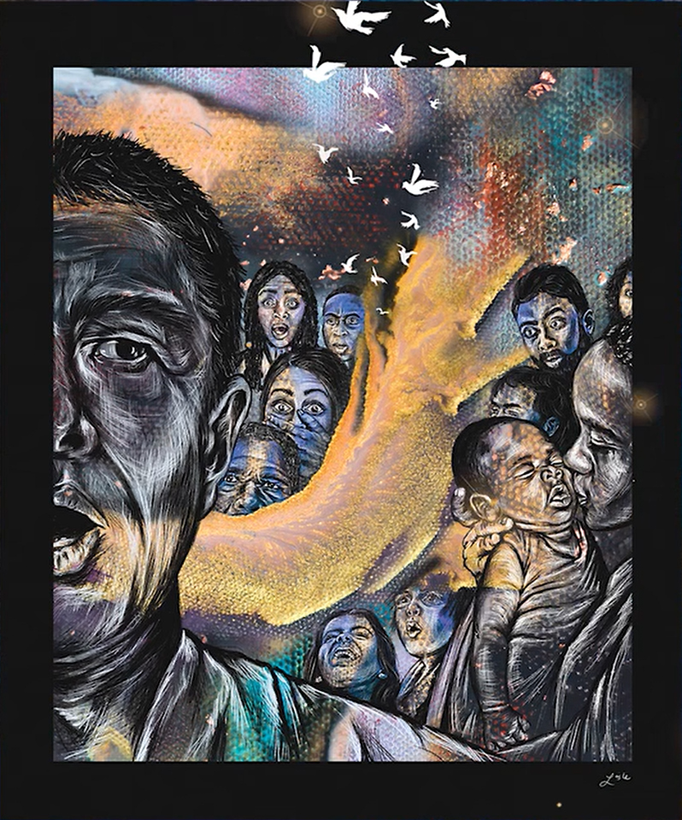
Come, Holy Spirit, renew the whole creation.
Send the wind and flame of your transforming life
to lift up the church on this day.
Give us wisdom and faith, that we may know
the great hope to which we are called.
Come, Holy Spirit.

Giver of life, sustain your creation.
Confront us with our greedy consuming of your gifts.
Stand before us as we pillage and destroy.
Call us forth into new harmonies of care
for all who live and breathe and have their being.
Come, Holy Spirit.

Spirit of truth, set us free to emerge as the children of God.
Open our ears, that we may hear the weeping of the world.
Open our mouths, that we may be a voice for the voiceless.
Open our eyes, that we may see your vision of peace and justice.
Make us alive with the courage and faith of your prophetic truth.
Come, Holy Spirit.

Spirit of unity, reconcile your people.
Give us the wisdom to hold to what we need to be your church.
Give us the grace to lay down those things that you can do without.
Give us a vision of your breadth and length and height
to challenge our smallness of heart and bring us humbly together.
Come, Holy Spirit.

Holy Spirit, transform us and sanctify us
as we take up this task in your name.
Give us the gifts we need to be your church in spirit and truth.
Come, Holy Spirit.

Amen.

To help us,
we sing together the prayer you use to teach your disciples:
The Lord’s Prayer.

The Lord’s Prayer (please use a version you are comfortable with)
Our Father in heaven,
hallowed be your name,
your kingdom come,
your will be done, on earth as it is in heaven.
Give us today our daily bread.
Forgive us our sins
as we forgive those who sin against us.
Save us from the time of trial
and deliver us from evil.
For the kingdom, the power,
and the glory are yours
Amen.

Listening to God



Children’s Time
Did you have to go outside for recess this week? Gym? Was it hot? When did it feel better? (shade, breeze)
A gentle breeze can feel great - especially on a hot day.
But a strong wind can be scary. Here’s a photo of a car, in this neighbourhood, after a storm. Near where my parents live an even stronger wind ripped apart some houses and a depanneur (aka the owl store).
That said, this photo shows how a strong wind can also be fun.

There are several stories in the Bible comparing God to wind - and it can be all of those things. God can be scary, powerful, exciting, fun, and make us feel better.

Prayer:
Dear Jesus.
Please be like a wind, refreshing us,
and blowing us to where we need to go.
Amen.

♫ Hymn: In Christ there is no east or west pg 9 (480)
www.youtube.com/watch?v=tEwLle8Ue4Y

Prayer for Illumination
Lord, open our hearts and minds
through the power of your Holy Spirit,
that we will be ignited by your passion.
Amen.

Intro to the readings
Today’s main passage comes even earlier in the Acts of the Apostles than last week. In chapter two we start with the community gathered in a building during the Festival of Weeks. This is a Harvest Festival for the first wheat crop and happens 50 days after Passover - which leads to the name for the Christian celebration of this event. The Greek word for 50th is Pentecost.
This was one of the Feasts that attracted pilgrims to Jerusalem, and they are in the story. Remember these two details. As pilgrims they would take their faith seriously enough to put their life on hold and take weeks or more to travel to make this pilgrimage. Some were born a Jew, while others had converted to Judaism. They all wanted to be good Jews and live as God wanted them to. While you may not have been on a long pilgrimage, I expect you can relate to their desire. The second detail? That it’s unlikely they were there 50 days earlier for Passover. They were not part of the crowd that called for Jesus’ execution. While this was a big event for the followers of Jesus, I wonder if they would even have heard of it - especially with the way the Christians were keeping to themselves. So, the crowd were people who were devoted to God, and likely hadn’t heard of Jesus’ death and resurrection.
We will also have a responsive psalm that picks up themes trusting God, and praying that this will work What wonder turns into
out; remembering God’s love and Gerrity
acknowledging that we sometimes fail to follow.
Both passages are great, and have been trimmed for length. Do read them again this week.
As you listen, feel where the Spirit of God is pulling your attention.


Reading: Please look up the passages in your own
Bible, or click on the name to be taken to an online version.
Acts 2: 1-15, 36-42 but all good
Psalm 25: 1-10 but all good

Sermon: Contagious Sharing
Dear Lord,
please bless the words of my mouth
and the meditations of all our hearts. Amen.

There are so many different sermons in these passages - not contradictory, just picking up on different themes. If you can remember later, I’d love to hear which attracted your attention. Perhaps it was the action and excitement, or how multicultural it is. or the theme of sin and grace, or the formation of a new community, or the dramatic change, or the hope, or the Passion of God igniting passion in the followers, ...or that Peter makes a joke.
One of the things that struck me is that this book is called ‘The Acts of the Apostles’, and the apostles definitely act in this story... but bigger than that are the Acts of the Spirit. It’s clear that without God’s Spirit, none of this would have happened.
The Spirit came to the community like a wind, like a fire, like something wild and powerful - needed and deadly. In the Bible Study we remembered that God had come in wind and fire before - to visit Moses on Mount Sinai... and later on Mount Sinai Elijah hadn’t found God in the wind and fire, but in silence. At the start of Jesus’ ministry he was baptized, “and the Holy Spirit descended upon him” not in wind and fire, or in silence, but “in bodily form like a dove.” The Spirit comes, but in different ways that accommodate different people. So if the idea of God coming into our midst “like the rush of a violent wind, and ... tongues, as of fire” isn’t something you look forward to, take comfort that this isn’t the only way. However there is something in common - what happens afterwards. The people go and share the Word of God’s ways.
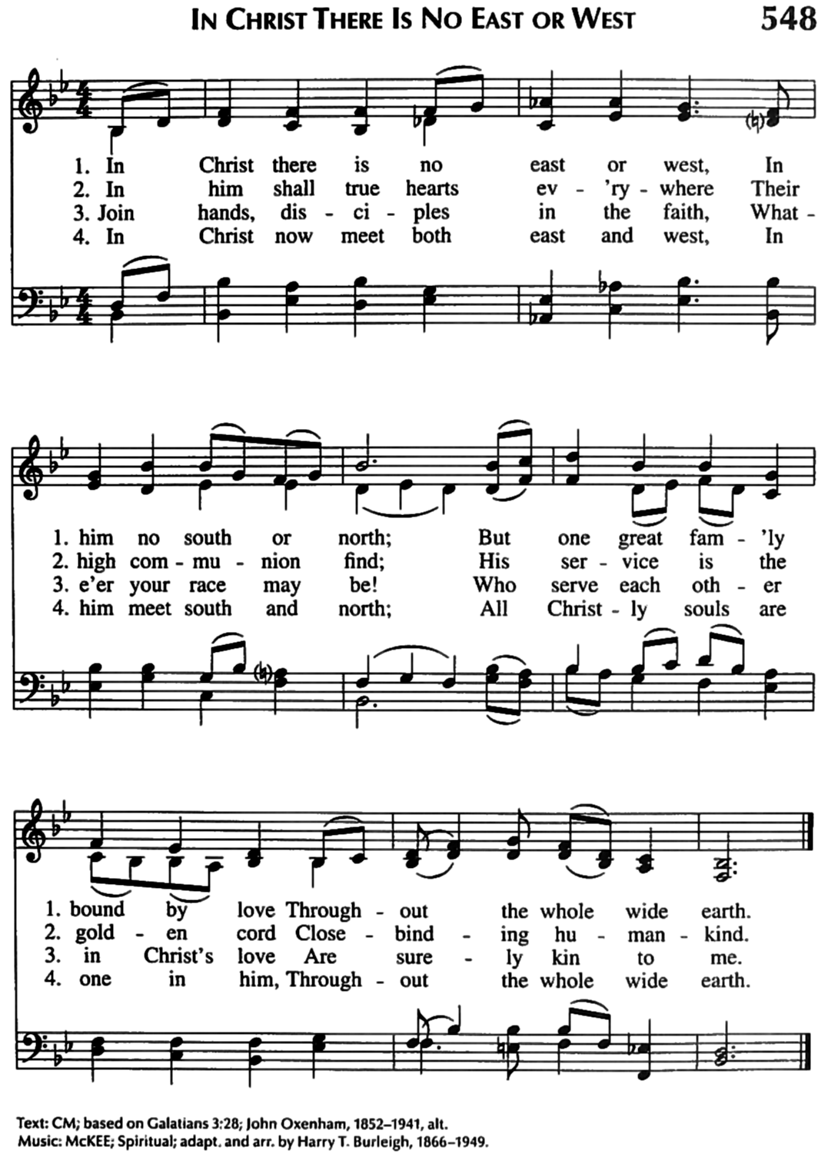
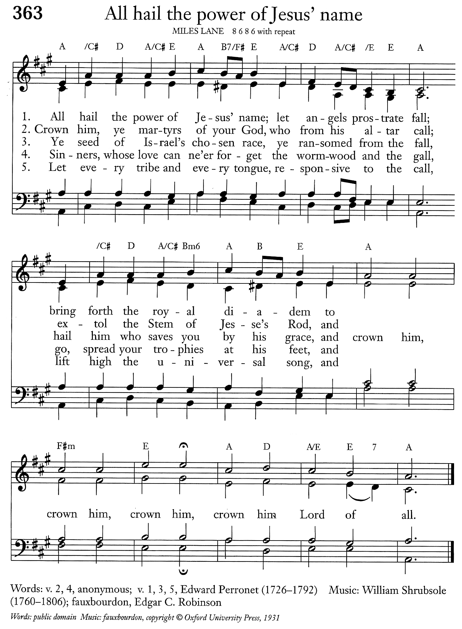
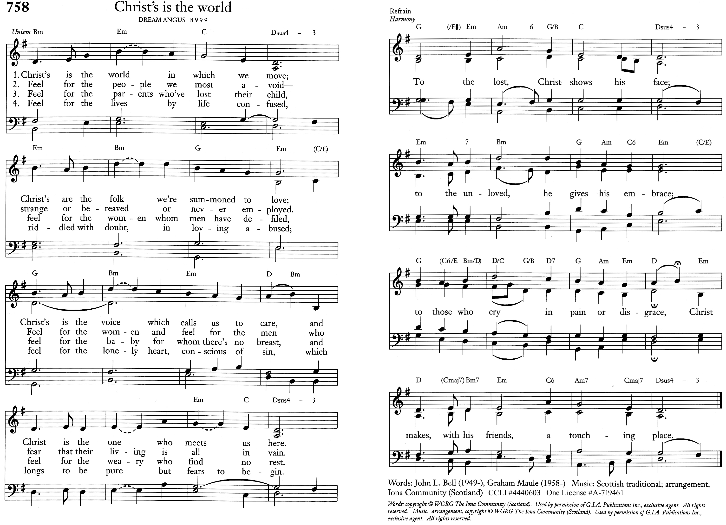
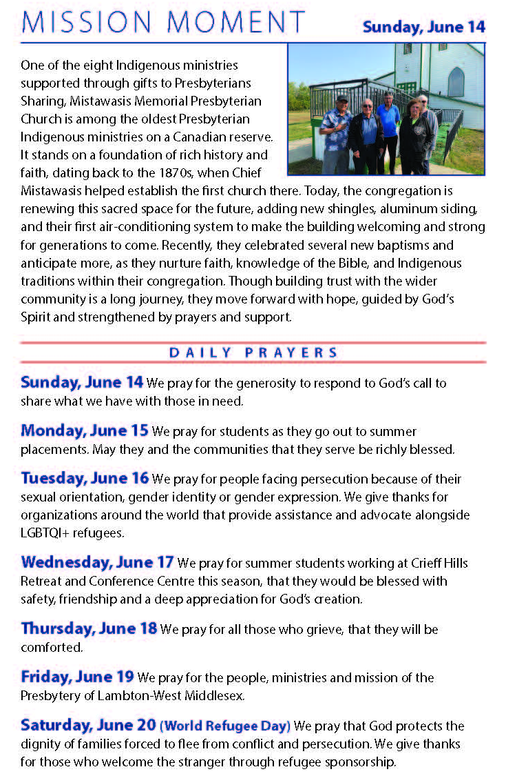
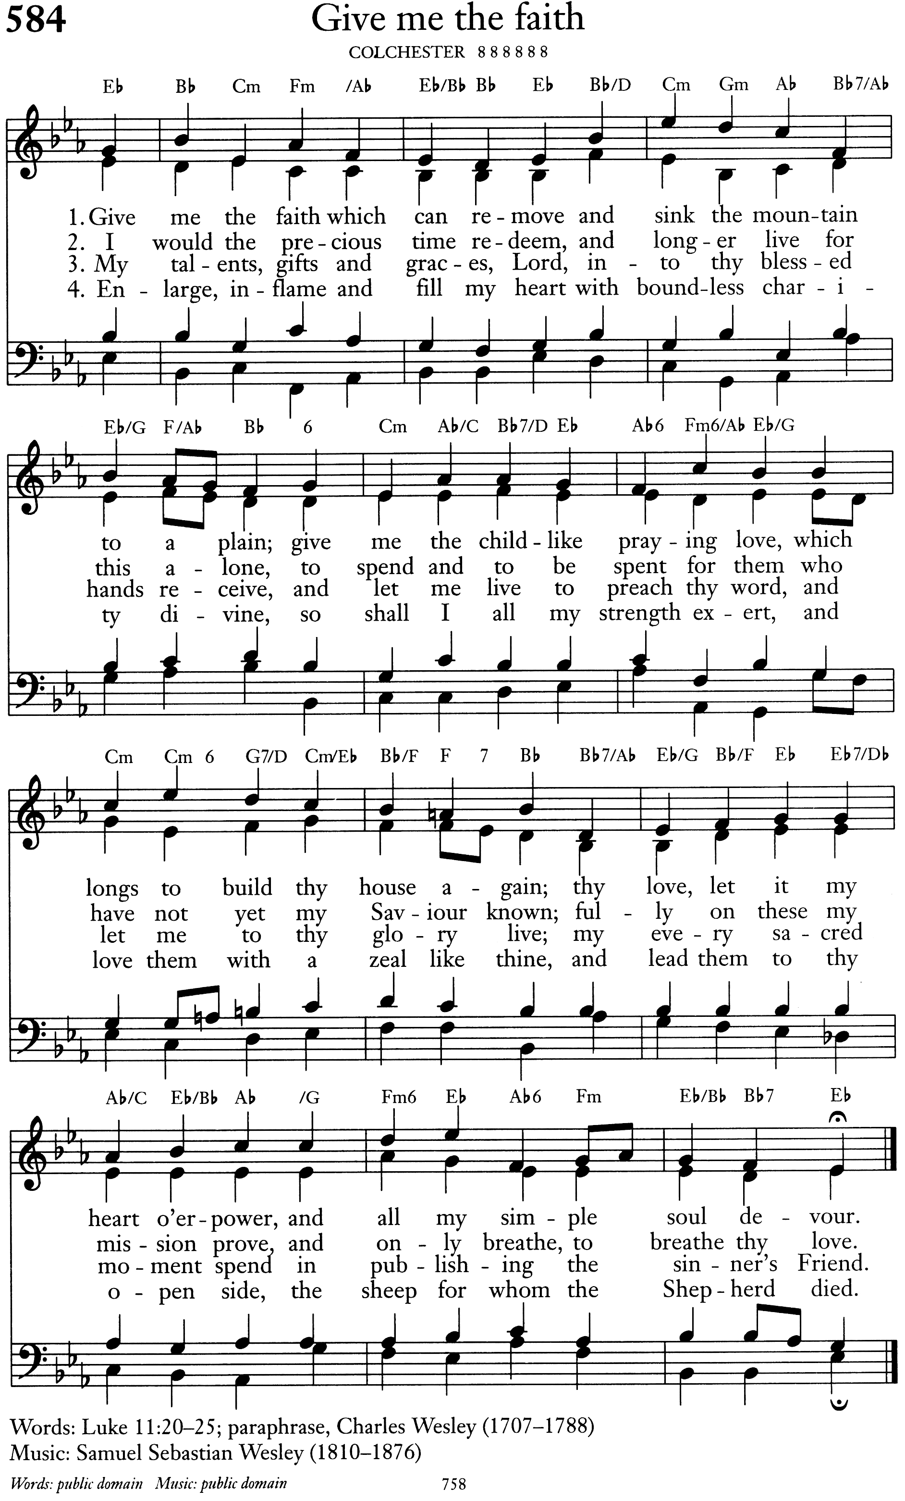
Of course, that was all in Biblical times. How does the Spirit come now? About a 100 years ago there was a wave of Christian revival going around the world that included more animated encounters with the Holy Spirit. The most famous and lasting is the American Pentecostal movement. They originally really focused on speaking in tongues - hence the name. They also believed that Jesus was coming back any day now - and so would dive into any idea for sharing the Good News as what did they have to loose. As the movement has aged they has broadened their focus a bit and now include more planning and committees than they used to, but there is still a strong culture or tradition of following where they feel the Spirit calling them without lots of studies. They trust that things will fall into place - which happens a surprising amount of the time. Various versions of Pentecostalism now make up about 25% of all Christians - in only 100 years. That’s huge. I don’t agree with all of their theology, but (to quote a famous Anglican priest (Barbara Brown Taylor)) “they must be doing something right.”
But this ‘dive in first’ and think after approach is hard for Presbyterians. We like to do things ‘decently and in good order’. Our structure, the way we do things, focuses on the importance of doing the work of God in a community.
Both work and community are in today’s passages. Let’s start with the community.

The followers of Christ have gathered together, all 120 of them. The Spirit comes and they go out to share the Word. Probably to everyone’s surprise their community expands... with 300 more interested in joining this movement of God. The Apostles are challenged to be open to new members - including those who had never met Jesus and would bring their own ideas. (And if you stop to think about it, this means a major shift in the culture of the group with over twice their number joining the community, and bringing with them ideas from around the world.)

One of the interesting things with immigration is that people walk into my office with questions that weren’t a part of my church culture growing up. They are looking for places to live, or jobs, or help with immigration papers. Why? Because in their culture you go to church for help with everything: answers to big questions and life and death, spiritual growth and support, ...and everything else. Can our culture be open to other ways of singing, praying, and what a church is involved in?
When talking to the crowd Peter does something I don’t feel would go down well in our culture. He talks about those sinful Jews who helped support the culture that killed Jesus. This passage has been used not to welcome, but to justify antisemitism - and that is wrong. There are two big issues with this. First, they are all Jew (religiously, not nationally). Even the ones not born Jewish have chosen to accept this religion. A bigger point is that they are all sinners. Even the great spokesperson Peter would include himself (with his famous denials in all four gospels). This is somebody from the inside saying that we all live in a way that is not healthy. We need to repent, to turn to a new way of living, and accept God’s grace. The community expands to include people who are part of a corrupt system, but are hoping for something better.
The community is also blatantly cross-cultural. This is a central theme in Acts. In this example we see that God doesn’t choose to have everybody understand one language. God embraces their diversity, and doesn’t let it be a barrier to hearing the Word. One way the Presbyterian Church in Canada helps is by supporting translating the Bible - most directly into three indigenous Taiwanese languages, and (I think) some West Coast indigenous languages.
Beyond sending money to Presbyterians Sharing, how can we help cross cultural barriers? Would it help to offer Ai instant translation over a cell phone app? Are there other barriers, such as our hymns, prayers, sermon style? This week at the General Assembly I was surprised to see that the Nanaimo NightClub church I mentioned the other week was awarded the Mission Award. Their worship is aimed at the culture of nightclub goers and is bridging barriers to a new group of non-church people. That’s not our calling, but it is a challenge to consider our culture/traditions.
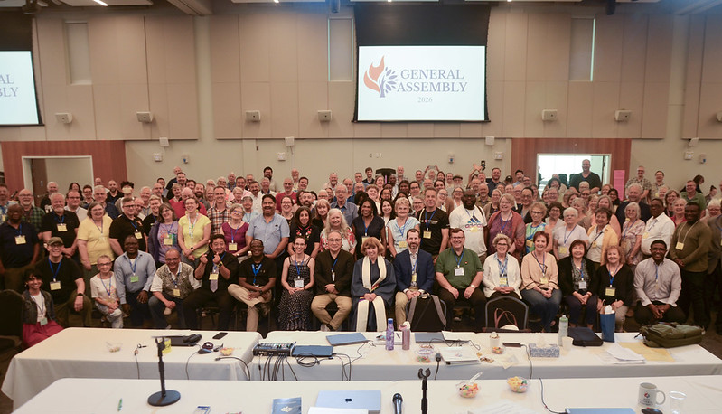
GA 2026
But we can’t forget the working. The early Christian community didn’t just sit there. They went out in a big show and connected with others. Here at Kensington we volunteer for things in the church and out (with more people volunteering this year). We open the building God has given us to community groups (which is also up from last year). But what about the sharing of the Word? What about telling people the source of hope or peace that we have found? Does this need to be a big attention getting event with shouting and dancing in the streets?
Like when Elijah met God in the silence and Jesus in a dove, I don’t think it needs to be a big spontaneous event. The Spirit works through committees...but only when the committee does more than consider. All this can be seen on the General Assembly videos from the past week (which you can now watch at faster than normal: presbyterian.ca/gao/ga2026).
That said, we can plan to include spectacles - activities that involve us going out of the building and talking with thosGod brings by. For example, next week we plan to have our lunch outside (God willing). If people come by, invite them in. Don’t tell them they are sinners, but listen to them. And consider what you’d say if they ask you why you come to church. What Good News can you share?

To God be all the glory
Amen.

Responding to God

♫ Hymn: Christs is the world pg. 10 (758)
www.youtube.com/watch?v=eiA3_OZNPWo

FaithTalk: These are some questions for you to discuss with
somebody... or many somebodies.
Do what you feel safe (and practice stretching a little).
Values: Why do you come to church?
Values: What do you appreciate about God?
Memories: Share a story that includes God.
Actions: invite somebody to our picnic
Actions: check out some of the videos or summaries from the General Assembly presbyterian.ca/gao/ga2026.
Prayer: ...that God’s passion will fire us up to reach out in ways that may be uncomfortable, but

Spirit Sightings
Check out the special guests to the General Assembly on video: presbyterian.ca/gao/ga2026

Offering
Financially, we have set up a donation option on our website: kensingtonchurch.ca. Just click the ‘Donate Now’ button, and then the pretty button. It gives you various options that are easy to follow.
You can also donate through interac e-transfer. Our name is Kensington Presbyterian Church and the e-mail address is info@kensingtonchurch.ca.
Mailing a cheque or signing up for Pre-Authorized Remittance (PAR) are also good options.

Prayers of the people
This week we will be passing around the prayer book and saying something based on what people write in it. You are welcome to create your own prayer or use this one from The Worship Sourcebook Q.4.4.6

We pray for God to fill us with his Spirit, saying,
Lord, come to bless us
and fill us with your Spirit.

Generous God,
we thank you for the power of your Holy Spirit.
We ask that we may be strengthened to serve you better.
Lord, come to bless us
and fill us with your Spirit.

We thank you for the wisdom of your Holy Spirit.
We ask you to help us understand better your will for us.
Lord, come to bless us
and fill us with your Spirit.

We thank you for the peace of your Holy Spirit.
We ask you to keep us confident of your love wherever you call us.
Lord, come to bless us
and fill us with your Spirit.

We thank you for the healing of your Holy Spirit.
We ask you to bring reconciliation and wholeness
where there is division, sickness, and sorrow.
Lord, come to bless us
and fill us with your Spirit.

We thank you for the gifts of your Holy Spirit.
We ask you to equip us for the work you have given us.
Lord, come to bless us
and fill us with your Spirit.

We thank you for the fruit of your Holy Spirit.
We ask you to reveal in our lives the love of Jesus.
Lord, come to bless us
and fill us with your Spirit.

We thank you for the breath of your Holy Spirit given on Pentecost.
We ask you to keep the whole church in the joy of eternal life.
Lord, come to bless us
and fill us with your Spirit.

Generous God,
you sent your Holy Spirit upon the Messiah at the river Jordan
and upon the disciples in the upper room:
In your mercy fill us with your Spirit,
hear our prayer, and make us one in heart and mind
to serve you in Christ, our Lord.
Amen.

♫ Hymn: Revive your work, O Lord pg 11 (284)
www.youtube.com/watch?v=NAucciFlOGU

Benediction
May the God of hope fill you
with all joy and peace in believing
so that you may abound in hope
by the power of the Holy Spirit.
Amen.

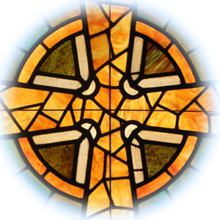

note: that the footnotes are not as thorough as an academic paper.
Worship Sourcebook Q.1.2.5
For those counting, that was May 24. You can check it out on our website as a PDF or link to YouTube: kensingtonchurch.ca/covid-opportunities
If you’d like a new Bible with helpful notes, I recommend the ‘Life with God Bible’ NRSV from Renovaré. ISBN 0061834963 or for the more academically inclined, The New Oxford Study Bible NRSV
I had a nice outline for a sermon on passion, but it didn’t feel right for this week
Luke 3:22
Which sadly emphasized a divisive theology (who’s in and who’s out) and can focus on individuals
For those who are curious, the Bible has apparently been translated into 776 languages - with the Newer Testament translated into another 1 798 languages.
You can want a presentation and explanation here: https://www.youtube.com/watch?v=5bgDJhzee0Y
Romans 15:13

